# Read Me

The .chm documentation  
If on opening the file documentation.chm, you see the message “Navigation to the webpage was cancelled” as depicted in the screenshot below.

[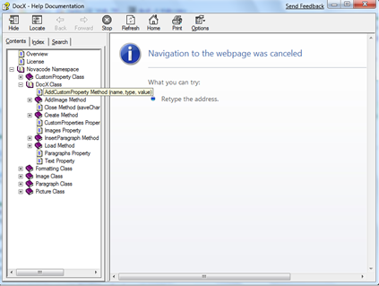](https://u8hm0q.bay.livefilestore.com/y1mVQpow_6gOlABIadJwxz9Two5yyo1jQqf_viaDSnYW9kLz_KDeqJrm4dSErjzR9n9whdbAppFlkGYLg8EH_9JID0BhtaDu7l2zrKXj4E8ZIh8Fq9R9wzQajHi3KItTmfZqU2lJuknpcHtd6b2kPhdFw/image%5B23%5D.png)

Then you need to right click on the .chm file and select properties.

[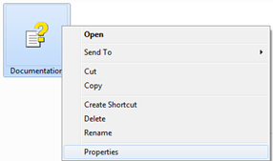](https://u8hm0q.bay.livefilestore.com/y1mTwzy5IFKAKWJa-oJ8kKscTqOfjkQzKSsTzIAUpc6kD9NI8T0WNE1YLa8FoMTxdt2ha63HDQGrv3gz7iv8nFzSnCPLwe51r-Q-Sg5atll1kEC88xLRXe8ypPac32Wq-dniCGVfx2YPF9ZlJ0L1pJu0g/image%5B10%5D%2017A43D77.png)

In the properties window, select unblock, and then press apply followed by ok.

[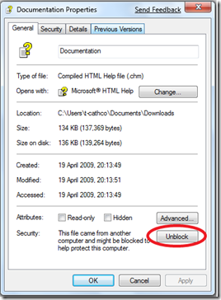](https://u8hm0q.bay.livefilestore.com/y1mhAYHgI8JPEBrC8Pk4dUJWE3kkXLTiZIet7KErfeooejm1XdQzqbNpfd31Q2FecuGdQRYePOBXcMYQbdiqZmYqHLMgJ9Dyd0-mWe4L01VLQZZwDLCKPuQHe2hMa5awOa-0syTx9Tnp4MqiZjQ0cO7KA/image%5B17%5D.png)

You should then be able to view the documentation and it should look similar to the below.

[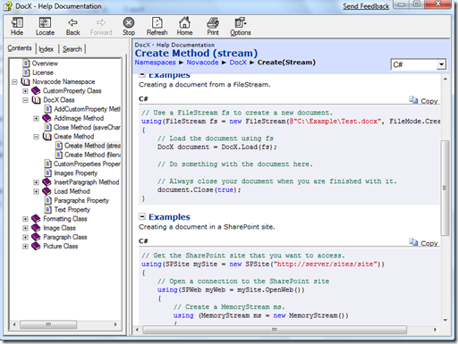](https://u8hm0q.bay.livefilestore.com/y1m7_FETMwVc6vEXb_iWy0SVVDYaAzyLxcA1cFf1FiEco5aT0j5e_hNLX8gCXqLTg7eAmy_Xf2VY9Uqy-a05KWg9j_XvVqI777bRibjyw-e_EJoZMkjf7Wt-WFYUUR1WzKmFjXEIW1Gpd3f4yTjUlLFNQ/image%5B22%5D.png)

The documentation contains lots of examples of how to use all of DocX’s features. If you find a mistake or simply wish to add a code example, please email me. If I think your example adds value to the documentation then I will gladly add it and note your contribution in the credits section.